**UML Diagrams**

1. Context Diagram

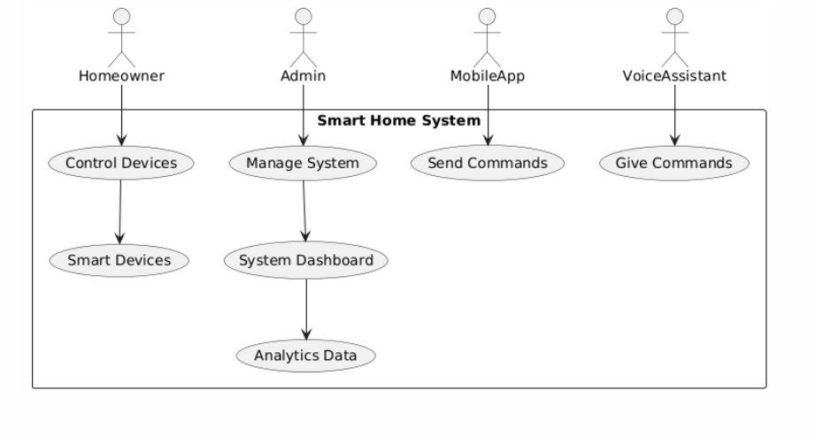

1. Data Flow Diagram

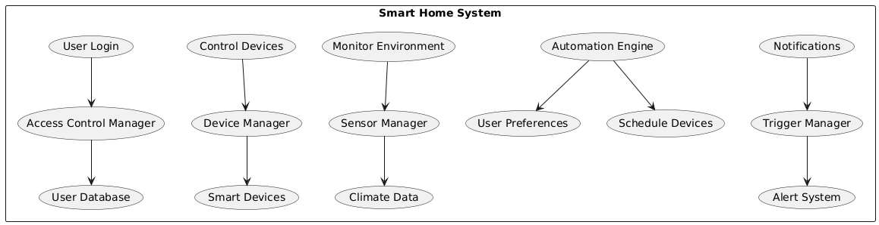

1. Class Diagram

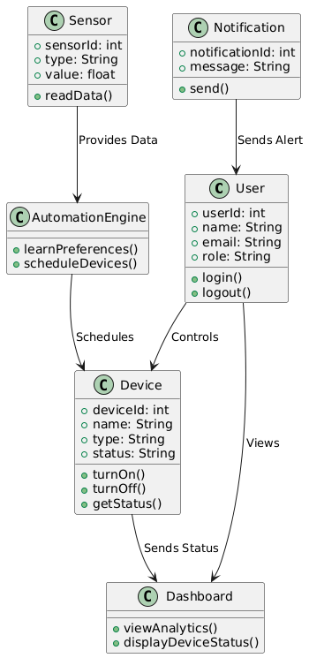

1. Use Case Diagram

